ThAA1

15.30 - 15.45

**Analysis of Telescope Arrays based Receiver for Deep-Space Optical Communications with Mars**

1. **Hashmi1, A.A.Eftekhar1, A. Adibi1, F. Amoozegar2**

*1 School of ECE, Georgia Institute of Technology, Atlanta, GA*

*hashmi@ece.gatech.edu*

* *Jet Propulsion Laboratory, Pasadena, CA Farid.Amoozegar@jpl.nasa.gov*

**Abstract**: Telescope arrays receivers are analyzed for deep-space optical communications betweenEarth and Mars. It is shown that data rates up to 14 M bits/sec are possible when Mars is at the farthest range from the Earth.

**1. Introduction**

NASA’s future deep-space exploration missions demand large bandwidth inter-planetary data links. Compared to RF technology, optical communication technology has the added advantages of higher gain smaller diameter antennas, a higher center frequency for extremely fast modulations, and a larger available spectrum. Hence, optical communication systems offer the potential for a substantial increase in current data rates from deep-space to Earth [1]. A telescope with large collecting aperture (≈10-m) is required at Earth to capture week optical signals transmitted from distant planets. A single large telescope has the limitations of high cost, single point failure in case of malfunction, and difficulty in attaining the diffraction-limited performance. An array of relatively smaller size telescopes is a viable alternative to a large monolithic telescope-based receiver [2,3]. Here, we present the design and analysis of a telescope array based receiver for an optical communication link with a spacecraft in Mars orbit, when Mars is farthest from Earth.

**2. Telescope Arrays**

A telescope array receiver is an aggregation of a number of relatively smaller sized telescopes connected to form a large total photon collecting area. Conceptual design of the telescope array receiver is given in Figure 1. Each telescope collects a portion of the incoming fields and focuses the energy onto its detectors. Each telescope is equipped with individual photo-detectors, photon-counters, front-end optical filters, clock, and fast steering mirror-based closed-loop tracking sub-system. Detected signals from all the telescopes are sent to a central combining unit via a high-speed digital network. Central combing unit combines the signals from all the telescopes after delay compensation and synchronization. The combined signal is further sent to the digital decoder for data extraction and information recovery. As opposed to arrays in interferometery, signals in the optical communication arrays are first optically detected at different array elements and then combined afterwards for the decoding purposes.

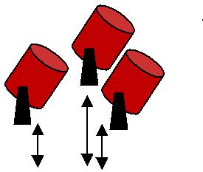

|  |  |  |  |  |  |  |  |  |  |  |
| --- | --- | --- | --- | --- | --- | --- | --- | --- | --- | --- |
|  |  |  |  |  |  |  |  | Transmitter power (W) | 5.0 |  |
|  | **Individual telescope** | | |  |  |  |  |  |
|  |  |  |  |  | Peak power (W) | 1.3 × 10 ³ |  |
|  | (a) Detector array | | |  |  |  |  |  |
|  | (b) Front end processing | | |  |  |  |  | Path loss (dB) | 372.47 |  |
|  | (c) Tracking | | |  |  |  |  | Transmitter telescope gain (dB) | 117 |  |
|  |  |  |  |  |  |  |  |  |
|  |  |  |  |  |  |  |  | Transmitter loss (dB) | 2.43 |  |
|  |  |  |  |  |  |  |  | Receiver loss (dB) | 5.58 |  |
|  |  | **Telescope control** | |  |  | **Cluster control** |  | Atmospheric loss (dB) | 2.5 |  |
|  |  | Signal synchronization | |  |  | Partial signal combination |  | Background loss (dB) | 5.3 |  |
|  |  |  |  |  |  |  |  | Background noise density, L | 5-130 |  |
|  |  |  |  |  |  |  |  |  |
|  | |  | |  | **High speed** | | | *µW* / (*cm* 2− *sr* − *nm*) |  |  |
| **Central processing** | | |  |  |  |  |
| (a) Array combining | | |  | **digital network** | | | |  |  |  |
| Optical filter bandwidth, nm | 0.1 |  |
| (b) Data detection and | | |  |  |  |  |  |  |
|  | decoding | |  |  |  |  |  |  |  |  |
|  | |  |  | |  | | |  | |  |
| Figure 1. Conceptual design of telescope arrays based receiver. | | | | | | | | Table 1. Link Budget parameters. | |  |

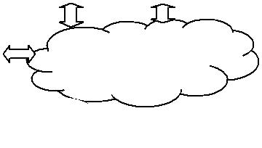

**978-1-4244-3681-1/09/$25.00 ©2009 IEEE** **831**

**3. Communication analysis**

The performance of the telescope array receiver is evaluated using both the analytical techniques and Monte-Carlo simulations. The main design parameters of the array architecture are the sizes of individual telescopes and the number of telescopes in the array. However, the total photon-collecting aperture of the complete telescope array receiver remains constant in each case. We start with a monolithic large telescope of 10-m diameter, i.e., the (1×10 m )

configuration. Then, we increase the number of telescopes in the array by breaking down the single aperture into 2, 4, 8, 16, 32, 100, and 135 elements of 7.07-m, 5-m*,* 3.53-m, 2.5-m*,* 1.76-m, 1-m, and 0.86-m telescope aperture diameters, respectively. Ideal photon counting detectors along with the Poisson probability model are employed for the signal and background photons. The signal and background photons received by each individual telescope are calculated according to link budget parameters given in the Table 1. The path loss represents the case when Mars is farthest from the Earth, i.e., (388 Million km., when in conjunction). Three different values for background spectral density are assumed namely, 5, 60, and 130 *µW* / (*cm* 2 − *sr* − *nm*) **,** that represent the nominal, average, and high

background conditions, respectively. Strong atmospheric turbulence conditions are assumed in the analysis by incorporating the Fried parameter value of 4-cm. Pulse-position modulation (PPM) along with the direct detection technique is employed. The detector field-of-view and the PPM slot width are optimized in each case to mitigate the background noise and turbulence effects. The performance of the telescope array receiver is evaluated using the Poisson analytical models [4,5] and Monte Carlo simulations.

The achievable data rates are given in Figure 2 for different background conditions. It is evident from the figure that the telescope arrays receivers perform similar to a large, monolithic telescope. There is a slight degradation in the performance, which is not noticeable. Analytical and Monte Carlo simulations results are also indistinguishable in the Figure. For the low background noise value of 5 *µW* / (*cm* 2 − *sr* − *nm*) , a telescope array receiver consisting of

100, 1-m diameter telescopes can achieve data rates as high as 14 M bits/sec. In moderate background conditions, 4.5 M bits/sec is possible. The Figure 2 also shows that in high background conditions, 2.5 M bits/sec can be achieved. This data rate capability in the worst channel conditions is still an order of magnitude larger than what can be achieved using RF technology in similar link conditions. Hence, telescope arrays based receiver architecture is a viable option for inter-planetary optical communications.

|  |
| --- |
| Achievable Data Rates, M bits / sec |

16

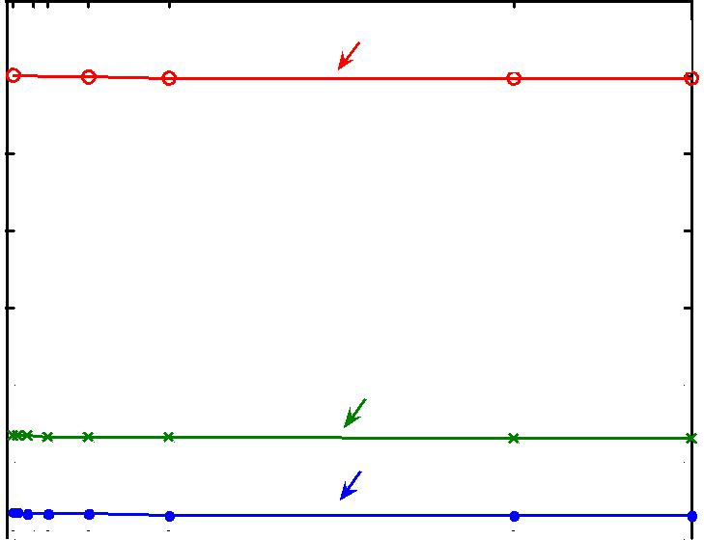

*L=5, Ts=2 n-sec, M=256*

14 

12

10

8

|  |  |  |  |  |  |  |  |  |  |  |  |  |  |  |  |  |  |  |  |  |
| --- | --- | --- | --- | --- | --- | --- | --- | --- | --- | --- | --- | --- | --- | --- | --- | --- | --- | --- | --- | --- |
| 6 |  |  |  |  |  |  |  |  |  |  |  |  |  | *L=60,Ts= 5 n-sec, M=256* | | |  |  |  |  |
|  |  |  |  |  |  |  |  |  |  |  |  |  |  |  |  |  |
|  |  |  |  |  |  |  |  |  |  |  |  |  |  |  |  |  |  |
| 4 |  |  |  |  |  |  |  |  |  |  |  |  |  | *L=130,Ts= 8 n-sec, M=256* | | |  |  |  |  |
|  |  |  |  |  |  |  |  |  |  |  |  |  |  |  |  |  |
|  |  |  |  |  |  |  |  |  |  |  |  |  |  |  |  |  |  |
| 2 |  |  |  |  |  |  |  |  |  |  |  |  |  |  |  |  |  |  |  |  |
|  |  |  |  |  |  |  |  |  |  |  |  |  |  |  |  |  |  |  |  |
| 0 1 5 8 | | | | | | | | 16 | | | 32 | | | 100 | | | 135 | | |  |

Number of telescopes in the array, N

Figure 2. Achievable data rates vs. the number of telescopes in the array. The aggregate aperture in each case is 10-m.

1. **References**
   1. H. Hemmati (Editor), *“ Deep Space Optical Communications,*” New Jersey: John Wiley and Sons, 2006 , pp. 1-4.
   2. V. Vilnrotter et al., “Optical array receiver for communication through atmospheric turbulence,**”** *Journal of Lightwave Technology*, vol. 23, no. 4, Apr., pp. 1664-1675, 2005.
   3. D. M. Boroson et al., “LDORA: A Novel Laser Communications Receiver Array Architecture,” *Proc. of SPIE: Free-Space Laser* *Communication Technologies XVI*, [Ed. S. Mecherle], vol. 5338, pp. 56–64, 2004.
   4. A. Biswas, S. Piazzolla, “Deep Space Optical Communications Downlink Budget from Mars: System Parameters,” in *IPN Progress* *Report*, Aug. 2003.

[5] R.M. Gagliardi and S. Karp, *Optical Communications*, 2nd ed., New York: John Wiley and Sons, pp.97, 203, 1995.

**832**